Instructions for adding RWHA affiliation code in MyVGL

Basic instructions:
- Go to https://vgl.ucdavis.edu/breed/red-wattle-hog and login or create a new account.
- Click Order Tests select Pig in the top menu bar.
- Select Pig Genetic Markers Permanent File Test Form
- Check Registration Affiliation and check Red Wattle Hog Association.
- Follow directions and fill out the rest of the form.

Screenshots:
1.
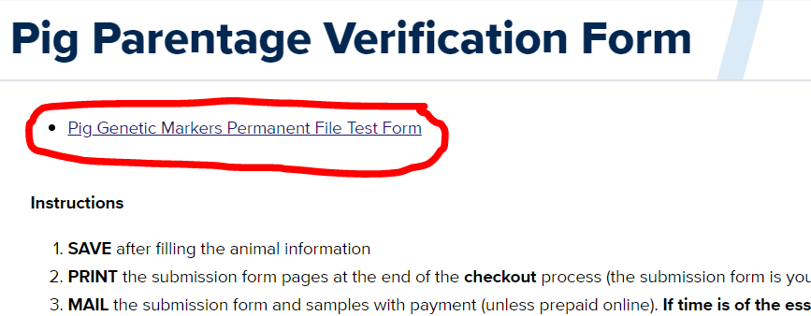

2.

